Robotics Process Automation Design and Development (UiPath) – BCG701 Lab
Experiment No: 11
Title: Develop Presentation automation in UiPath StudioX to demonstrate the following activities: Use PowerPoint Presentation, Copy Paste Slide, Delete Slide, Add New Slide, Add Text to Slide., Add Data Table to Slide, Add Image/Video to Slide, Save PowerPoint File As., Save Presentation as PDF.

Aim: To develop an automation in UiPath StudioX that demonstrates Presentation automation by performing operations such as:
- Use PowerPoint Presentation
- Copy Paste Slide
- Delete Slide
- Add New Slide
- Add Text to Slide
- Add Data Table to Slide
- Add Image/Video to Slide
- Save PowerPoint File As
- Save Presentation as PDF

Theory:
- Use PowerPoint Presentation: The Use PowerPoint Presentation activity allows you to select the PowerPoint presentation that you want to automate. This activity will contain all the actions that you want to take on the PowerPoint. For example, if you want to add a new slide, the Add New Slide activity will be nested in the body of Use PowerPoint Presentation activity.
- Copy Paste Slide: The Copy Paste Slide activity allows you to copy or move a slide within the same PowerPoint presentation or from one PowerPoint presentation to another.
- Delete Slide: The Delete Slide activity allows you to delete a specified slide from a PowerPoint presentation.
- Add New Slide: The Add New Slide activity allows you to add a new slide to the PowerPoint presentation.
- Add Text to Slide: The Add Text to Slide activity allows you to add text to the specified placeholder on a slide.
- Add Data Table to Slide: The Add Data Table to Slide activity allows you to add a data table to the specified placeholder on a slide.
- Add Image/Video to Slide: The Add Image/Video to Slide activity allows you to add an image or a video to the specified placeholder on a slide.
- Save PowerPoint File As: The Save PowerPoint File As activity allows you to save the referenced PowerPoint file as a different PowerPoint file type including .pptx, .pptm, and .ppt. The Save PowerPoint File As activity only saves a powerpoint file to .pptx, .ppt, and .pptm types.
- Save Presentation as PDF: The Save Presentation as PDF activity allows you to save the referenced PowerPoint presentation as a PDF file.

Conduction:
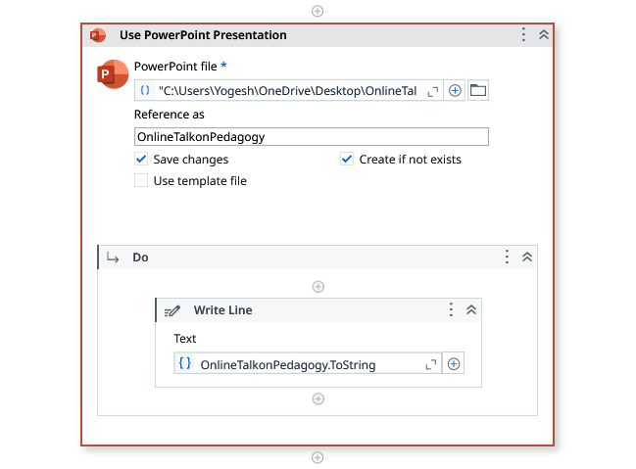

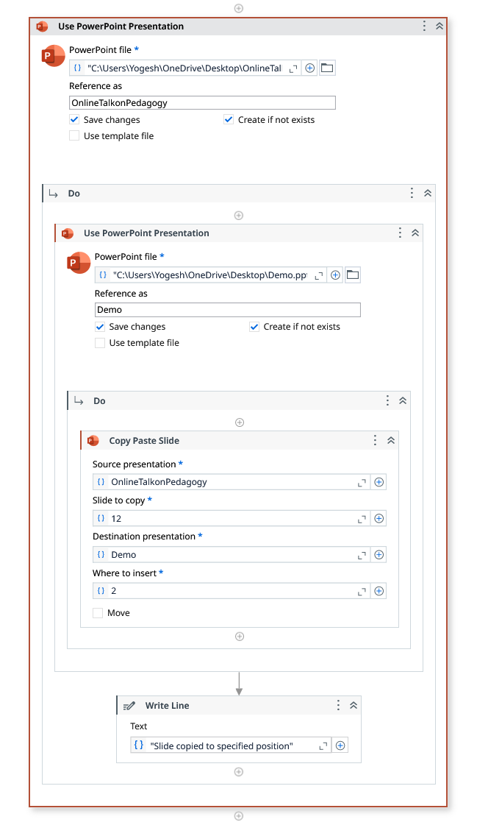

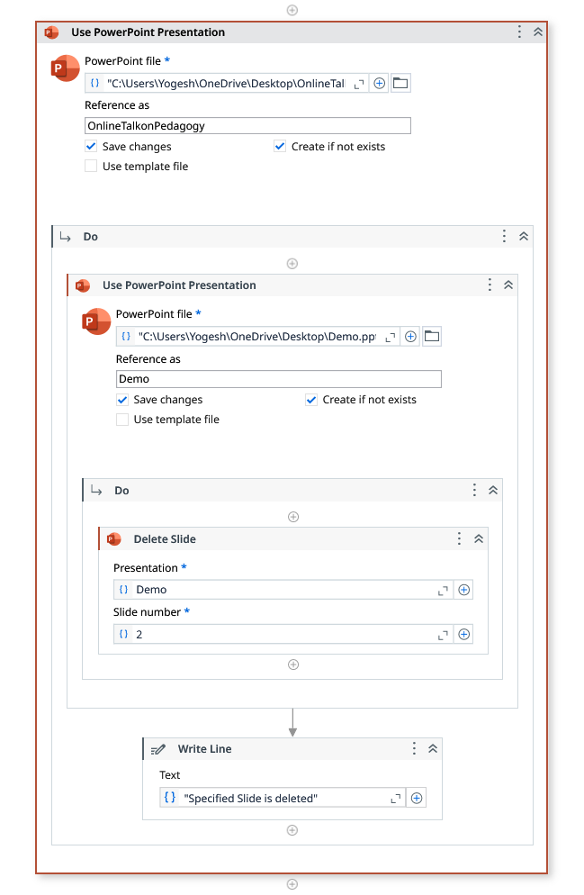

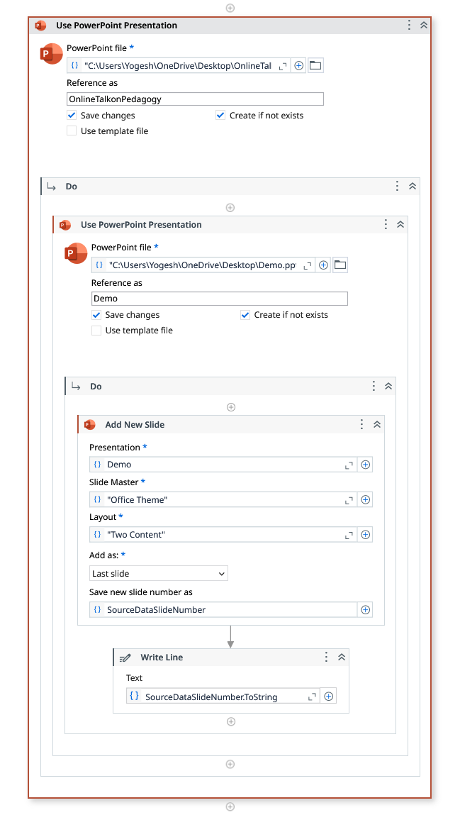

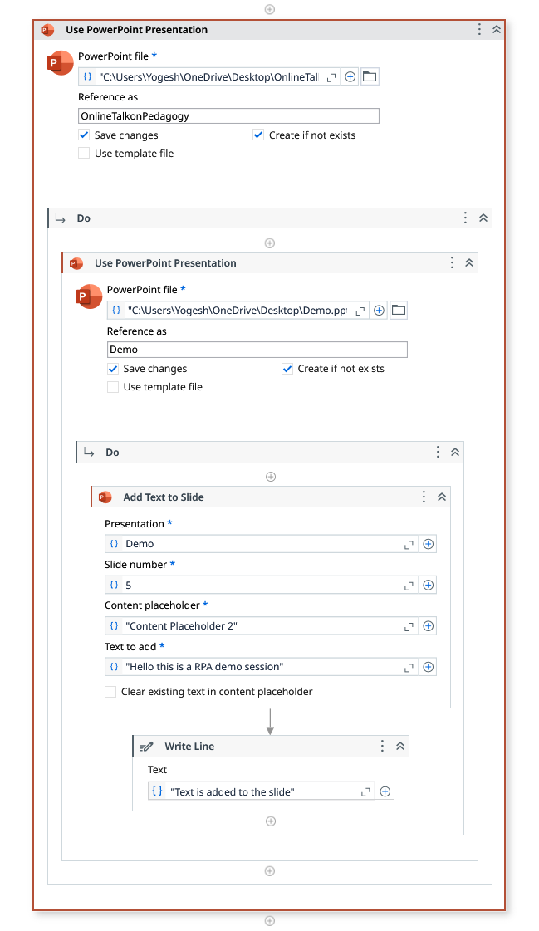

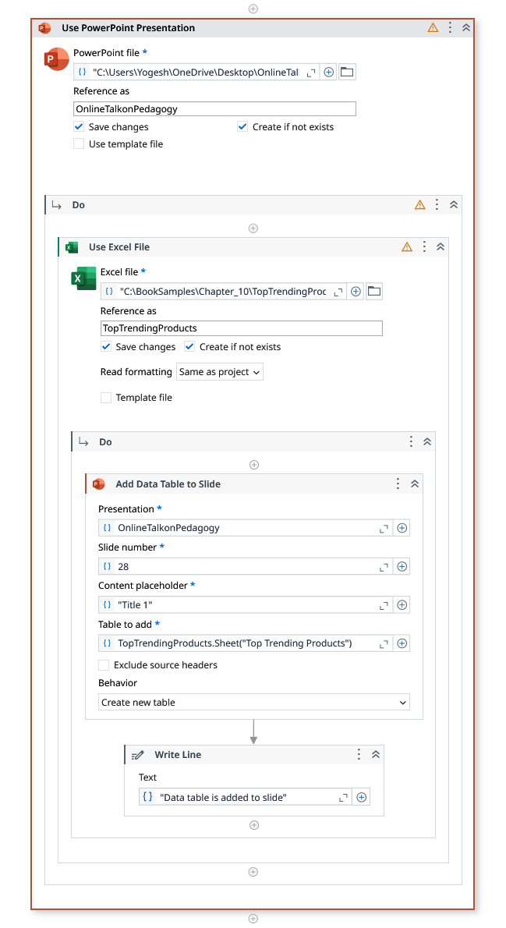

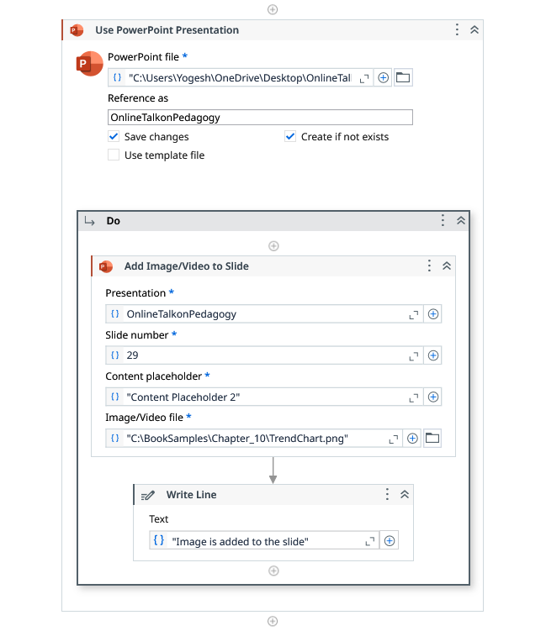

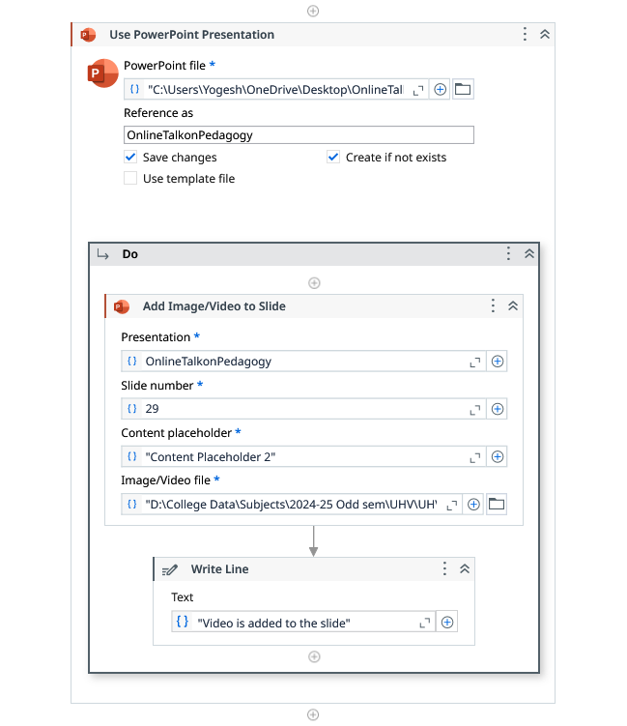

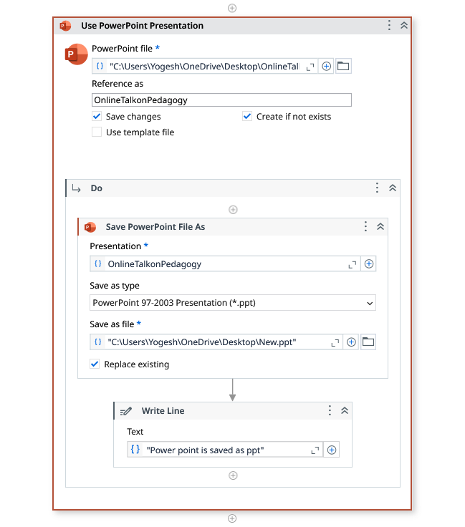

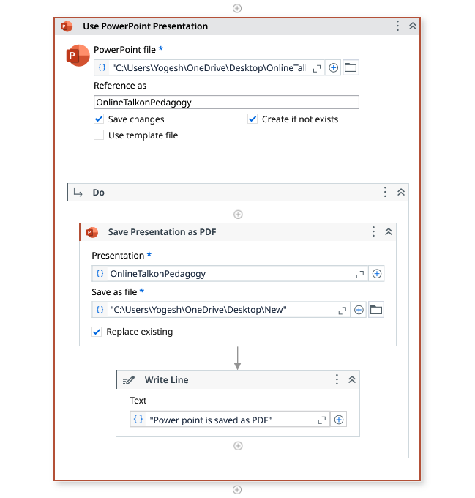

Output:
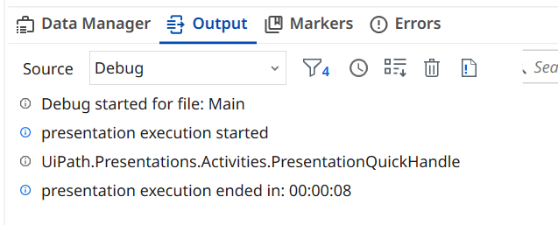
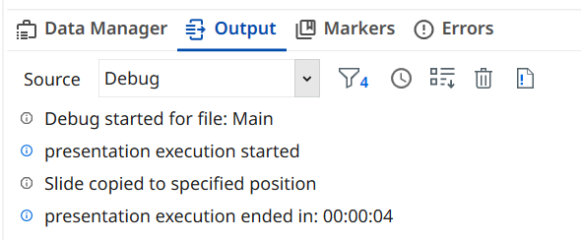

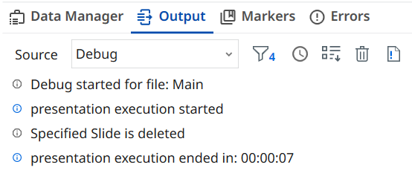
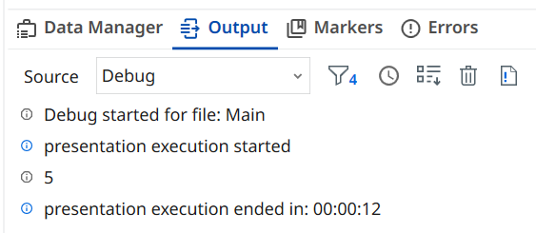
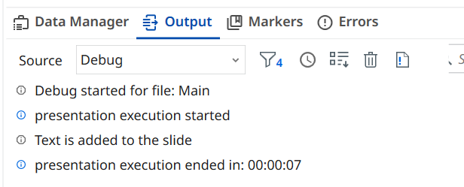
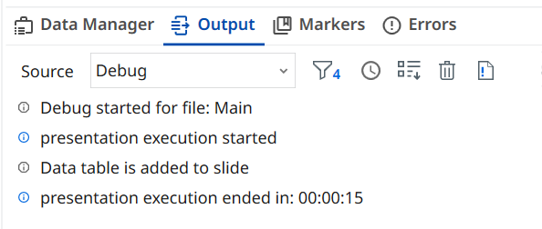
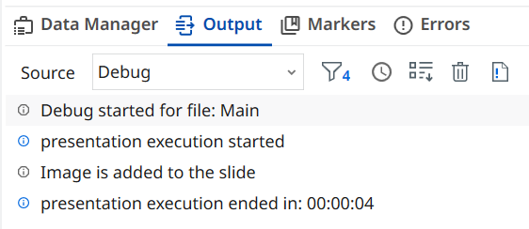
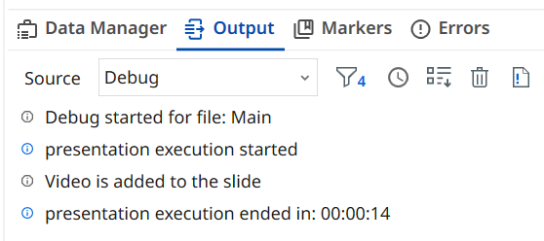
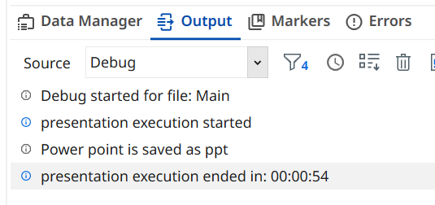
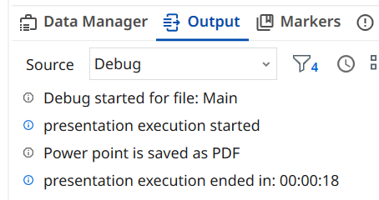

Observation and Results:
The following activities were successfully demonstrated in UiPath StudioX:
- Use PowerPoint Presentation
- Copy Paste Slide
- Delete Slide
- Add New Slide
- Add Text to Slide
- Add Data Table to Slide
- Add Image/Video to Slide
- Save PowerPoint File As
- Save Presentation as PDF
The output for the above-mentioned activities is verified.

Evaluation:
Evaluation Parameters | Maximum Marks | Obtained Marks
Conduction | 8
Record Writing | 4
Viva | 3
Total | 15

Signature of the Faculty in-charge with date:

